1. Pull the key headers.
bash
grep -iE 'return-path|authentication-results|spf|dkim|dmarc|^from|reply-to|^to|subject|x-mailer' phishing_sample.eml
Findings –

Sender Ip – 193.42.61.204
Sender Domain – office365-support-desk.com – If is was from Microsoft the mail id will be different and they wont be any name as in this mail it is Microsoft 365 security it woulb be only something like (no-reply—x-x.com)
Reply to domain – mail-sec-team.com – No one tells to reply to a different domain
Subject – [ Action Required ] – It stated urgency and using pscylogical fear
x Mailer – PHPMailer 6.1.7 – Bulk Php mailing library. Used for spamming mails and used by spammers.
So The email failed the three important authentication checks. Firstly senders Ip is 193.42.61.204 and it failed SPF check which is SPF=Fail . It means that send is not authorised to send mail from that Domain. Second DKIM=None , message was not signed , means the message did not prove the signature that it is coming from the right or original domain , means it is been tampered or it is a fake mail. Third DMARC=fail and it did not accepted the domain policy so p=quarantine means we need to move this to junk folder.
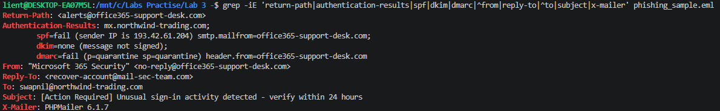
2. Extract every URL in the body.
bash
grep -oE 'https?://[^"<> ]+' phishing_sample.eml
3. Look at the actual link vs. what it displays. Open the raw file and find the <a href=...> line:
bash
grep -A1 'href' phishing_sample.eml
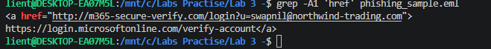
Findings- Display Link - https://login.microsoftonline.com/verify-account
Destination Link - hxxp://m365-secure-verify[.]com/login?u=swapnil@northwind-trading.com
(I wrote it as hxxp and [.] — that's called defanging. Analysts do this in reports and chats so nobody accidentally clicks a live malicious link. Get in the habit of it.)
Finding – The link displayed with claim it is from Microsoft but it was going to somewhere else entirely. So it was a lookalike domain. The destination link includes m365-secure-verify which is a lookalike domain to pretend it is from Microsoft so it looks like it is legitimate. Also the destination link has the victims email address prefilled which is a red flag , and Microsoft does’nt mention this in URL.Also the url has http not https – so no encryption on a page askin for credentials so mean is is fake where a real login page is always https.

